
FALL 2016

SMTRA Newsletter
simcoemuskokatra@gmail.com www.facebook.com/smtra simcoemuskokatra.wix.com/smtra

In This Issue  -Greetings & Well wishes  -Upcoming Events & Happenings  -TRO Ambassador Role Update  -Christmas Tea Program  -Christmas around the World  -Dear Santa: Resident Wish List  -Influenza: Help us protect our residents  -Fall Recipes: Breaking the Bread  -Jokes and Riddles | Greetings from the Executive Committee  Hello SMTRA Members! We hope you are keeping warm and dry this fall. Thank you to everyone who came out to our meeting at Georgian College last month. We want to remind everyone that our AGM is tentatively scheduled for Feb 15th, hopefully from multiple sites (via video conferencing). More details to follow.  In the meantime, please read on to get some cozy activity ideas to spice up your cold weather programs!  Hali  SMTRA President  Upcoming Events to look out for:  Country Jam every Friday night @ Askennonia Seniors Centre- Midland  Saturday Night Dances @ Army Navy & Air Force Club – Barrie  Cookstown's Annual Light Up Night - Friday, November 11, 2016 6:00 PM - 9:00 PM  Christmas Craft Show @ Army Navy & Air Force Club – Barrie  Saturday November 12, 10:00am  Georgian Bay Grannies Art Show & Sale Reception @ Collingwood Public Library – Sunday Nov 13 1:00-4:00pm  Celebrate Christmas @ Bradford West Gwillimbury – Friday December 02, 2016 6:00 PM - 8:30 PM  Christmas, Past and Present @Simcoe County Museum  Thursday, December 08, 2016 - Friday, December 09, 6:00 PM  Frozen in Time Ice Sculpture Festival in Collingwood  Tuesday, December 27, 2016 12:00 AM - Sunday, January 01, 2017 11:59 PM

November 2016  Ambassadors for All Regions  TRO’s Membership and Professional Services Committee would like to formally announce and welcome our 4 new Regional Group Ambassadors:  Julie Pollock – South West Ontario  troambassadorsw@trontario.org  Lisa Scriver – Central Ontario  troambassadorctl@trontatio.org  Sara Richardson-Brown – South East Ontario  troambassadorse@trontario.org  Rhiannon Buffet – Northern Ontario  troambassadornorth@trontario.org  The TRO Regional Ambassador is a liaison between the board of directors and regional groups or individual TR’s to enhance two-way member communication.  This role was first discussed at the 2015 TRO Conference as a way to increase communication, support Regional Therapeutic Recreation Associations in Ontario, and bring together TR’s from across the province. It is our pleasure to announce that all 4 Regions across Ontario now have an Ambassador to represent them.  Ambassadors have been busy locating and connecting with all the TRs in their region.  WE WANT TO HEAR FROM YOU!  Feel free to contact them and start the conversation!!  https://trontario.org/regional-ambassadors | "Cup of Christmas Tea" party idea  The well-known book “A Cup of Christmas Tea” by Warren Hanson has become a classic.  About nostalgia and a visit to an aging Great Aunt, it’s a favorite of the older generation.  Written in rhyme, it is delightful to read aloud to a group while enjoying a cup of tea served the old-fashioned way in good china if possible, with nice table linens and holiday treats!  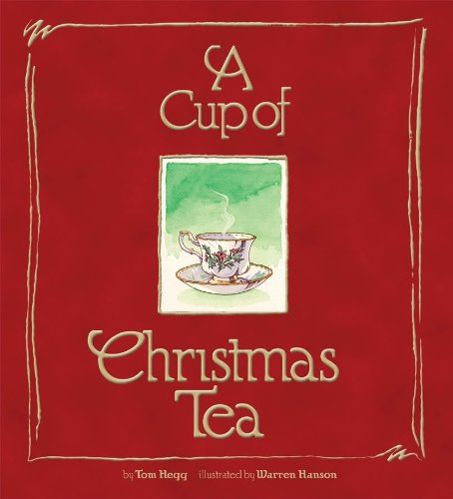  Sharing cultures    Almost everyone celebrates something during the winter months. So why not celebrate a special open house activity? Decorate in the traditional manner, bake or cook special foods, and play holiday music.  You can host a “snack and learn” event where you discuss traditions from across the world such as Ireland, Germany, Scandinavia, France, Italy, Greece, South America, as well as Israel, Africa, India, and the Middle East. You can even add an element of trivia or slide show with pictures.  A great social learning activity!
November 2016  Help Us Protect Your Family Members, Friends, and Clients    Flu season is now upon us and as The Public Health Agency of Canada has written, “As the number of people who get immunized increases, the probability of infectious disease transmission decreases. As a result, the community resistance to the disease becomes stronger in a way that provides a protective barrier” keeping our resident population better protected. This collective protection is called “herd immunity.”  What is it?  Influenza is a virus that causes respiratory illness in people of all ages. Influenza types A and B are the two main types that cause yearly outbreaks. In Canada, the influenza season usually runs from November through April.  What are the symptoms?  Influenza is associated with a sudden onset and may cause:  • fever - elderly people may not always develop a fever  • loss of appetite • headache  • sore throat • fatigue  • sneezing • dry cough  • runny nose • muscle aches  Who is at risk?  Certain groups are at risk for developing serious illness and/or complications, including:  • people with underlying medical conditions including; chronic respiratory disease (e.g. asthma), heart or kidney disease, diabetes, or a weakened immune system  • very young children  • pregnant women  • people aged 65 and older | How can the spread of Influenza be reduced?  • Getting the influenza immunization yearly.  • Frequent and thorough hand hygiene.  • Staying home when sick.  • Covering your nose and mouth when you cough and sneeze, using your sleeve or disposable tissue.  What should I do if I get sick with Influenza?  • Stay at home and away from others until your symptoms are gone.  • Get plenty of rest and drink lots of fluids.  • See your health care provider if symptoms worsen or become severe.  Source: Public Health Agency of Canada, Public Health Ontario, HKPD Health Unit.  When do symptoms start?  Usually one to three days after coming in contact with the virus.  When is it contagious?  People with influenza are considered contagious up to 24 hours before symptoms start until five days after the start of symptoms. Children may be contagious for up to seven days after the start of symptoms.  How does it spread?  Influenza spreads easily from person-to-person through contact with droplets from the nose and throat of infected people when they cough and/or sneeze. Influenza can also be spread through contact with objects soiled with discharge from the nose/throat of infected people (e.g. tissues, hands, toys, countertops, etc.).  How is it treated?  For most healthy people, influenza is allowed to run its course. High-risk people may be placed on antiviral medications to help reduce symptoms and shorten the length of illness.  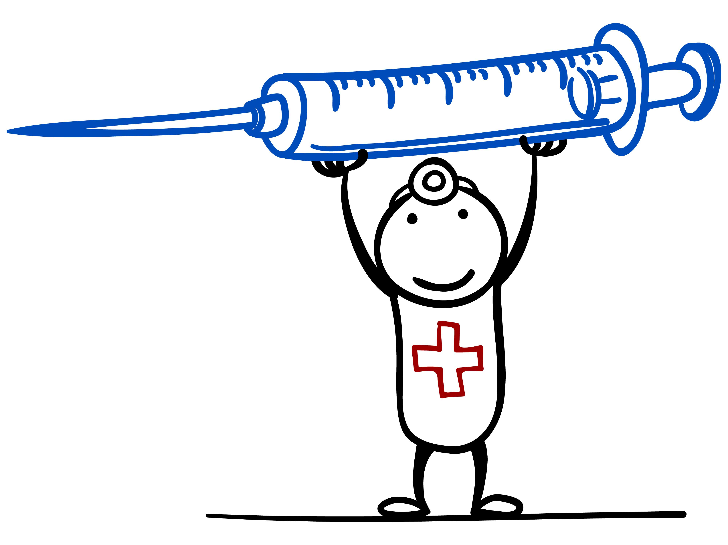
Christmas Wish List’s  “Dear Santa” Letter Week starts November 7–13, 2016!  If you work in LTC, or even general health care, having a ‘Resident Wish List’ can help families know what to get their loved one(s), as chosen by them.  HOW IT WORKS: Each resident has a wish list in his or her room, allowing staff, family, and residents to write down what they may need this year. Remember to write down the size, brand name and any other important details as these things often change through the year.  TIP: Research states that the two most popular gifts to start the new year off right are pajamas & slippers!  Other ideas include having a day to create a collage of items your clients like; this can help their family members as well. Use old wish books or catalogues from stores.  Bread Baking  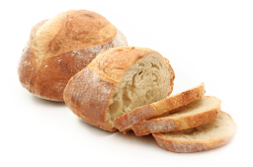  On November 17, Homemade Bread Day, follow these tips for baking the perfect loaf:  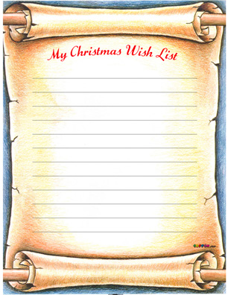  Yeast may be the most important ingredient in bread because it creates the bubbles that make bread rise. There are two common types of yeast: instant and active dry. Active dry needs to be proofed (dissolved in warm water) and given more time to work.  Kneading is important to help the dough keep its shape while the yeast develops gas and inflates the dough like a balloon. After kneading, you must wait. Your dough should roughly double in size.  A good test of doneness is to press your finger into the dough. It should leave an impression.  Have some left over pumpkin from Thanksgiving?? Give our pumpkin bread recipe a try!  November 2016 | Pumpkin Loaf Bread  - 3 cups sugar  - 1 cup oil  - 3 large eggs  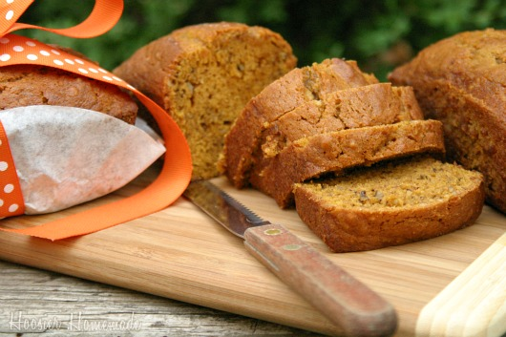  - 1 (15-16 oz) can solid pack pumpkin (be sure its not pie filling)  - 3 cups flour  - 1 teaspoon ground cloves  - 1 teaspoon ground cinnamon  - 1 teaspoon ground nutmeg  - 1 teaspoon baking soda  - 1/2 teaspoon salt  - 1/2 teaspoon baking powder  - 1 cup walnuts, coarsely chopped  Instructions  - Preheat oven to 350 degrees  - Beat sugar and oil in large bowl  - Mix in eggs and pumpkin  - Sift dry ingredients in another bowl  - Add dry mixture to pumpkin mixture  - Fold in walnuts  - Divide batter into greased pans.  Bake until toothpick comes clean, about 40 – 45 minutes for mini loaves, and 1 hour 10 for large pan  Cranium Crunchers & Riddles  1.How do you make an egg laugh?  Answer: Tell it a yolk.  2.What bird can lift the most?  Answer: A crane.  3. What can you hold without ever touching it?  Answer: A conversation.  Jokes Corner  "Ralph how you are getting so good at golf these days?" one golfer asked another. "I'm a scratch golfer; I write down all my good scores and scratch out all my bad ones."

